Owls and Wrens

Term 4 Weeks 1-6

Once upon a time
In science this term we will continue to think about what keeps us healthy! We be sorting foods into groups, thinking about what we need to eat and foods that we need to only have as treats! We will also be learning that exercise, sleep and keeping clean all helps to keep us healthy. Year 1 children will be learning about the function of different body parts and our senses. We also have a number of STEM- based experiments planned and we will be using our senses to make observations.

What’s on…
- Parents evenings.
- Library visit

In our topic work we will be reading lots of fairy tales and stories. We will be learning about important events and people in British history, including some of the famous Kings and Queens of England. We will learn about where is the best place to build a castle and we will draw maps to show our ideas. We will learn how to make models stronger by reinforcing them with additional materials and we will learn how to making moving parts by adding a feature like a drawbridge or a portcullis. In Music we will be exploring the sounds different instruments make. We will be composing some musical pieces to accompany the story of Jack and the Beanstalk.
As mathematicians in FS2 we will continue to learn to recognise, count and order numbers and to say what is one or two more than any number up to 20. In Y1 we will split 2 digit numbers into tens and ones and compare the size of 2 numbers. We will learn to double and halve numbers using practical objects (FS2) and Y1s will learn to recall some from memory. We will continue to learn to solve simple problems with objects (FS2 children) and using the number line (Y1s).
To help with your child’s learning at home:
- Encourage your child to identify the coins you need to pay for an item at a shop. Do they know the colour of a £1 coin? Allow them to ‘sort’ the change in your purse or pocket. Which coin is worth the most? Can they count the amount of 10ps by counting in tens?
- Can your child tell you the story of Jack and Beanstalk at bedtime storytime? What happened at the beginning of the story? What happened next? What happened at the end? Can they change the story so that there is a different ending? Or encourage them to think of a different main character? What do they think they would find if they climbed up a beanstalk in your garden?
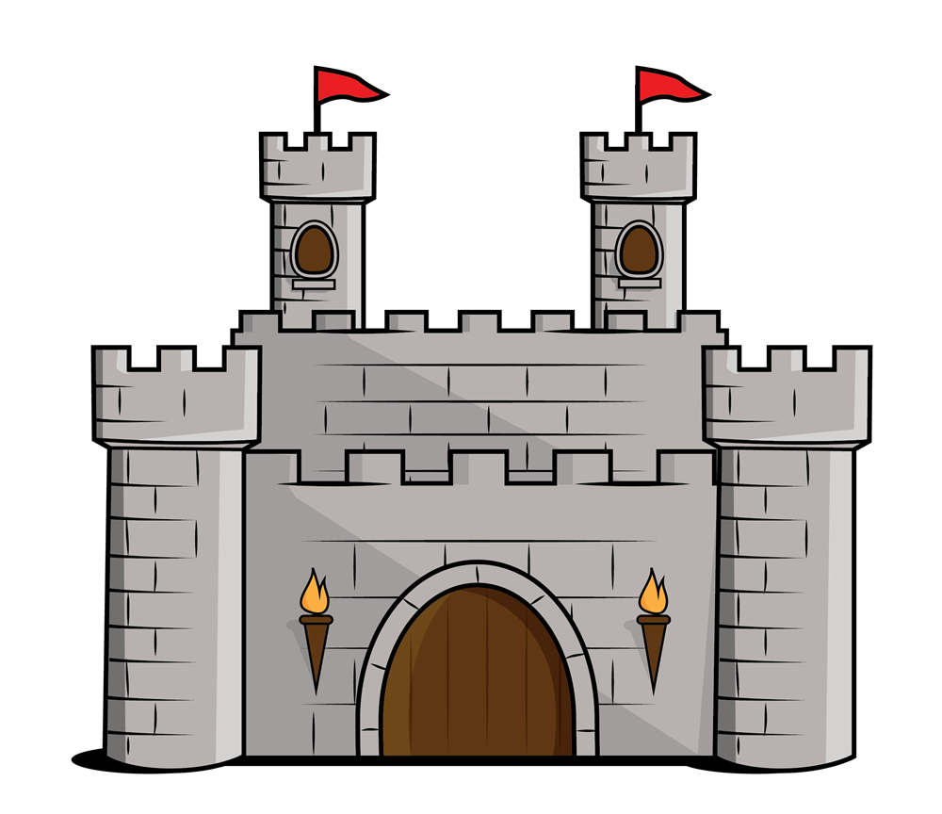
As readers we will continue to learn to blend phonemes to read simple words. Year 1 children will also have words and spellings to practise. Please continue help your child to practise and consolidate all of their phonemes and read words on their keys.
As writers we will learn to write sentences. Year 1 children will continue to learn to use capital letters and full stops correctly and write a number of linked sentences. FS2 children will learn to sequence stories. We will be focusing on the traditional story Jack and the Beanstalk and a number of non-fiction books about castles.
As communicators we will be learning to orally retell the story of Jack and the Beanstalk. We will also be learning to talk about what we have learned about our space topic.

