Term 2 Weeks 1-8

**Robins and Starlings**

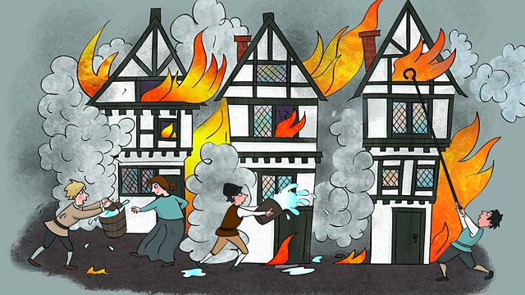

As **readers** we will continue to work our way through the Little Wandle phonics scheme. Please continue practising the high frequency words and common exception words sent home as spellings each week. The children need to be able to read these by sight to help to build their fluency. During our whole class reading sessions, we will be learning to answer simple comprehension questions about different texts.

As **writers** we will be focusing on forming letters in the correct way. We will practise writing at length in order to build up our writing stamina. We will begin the term by creating some Firework poetry and we will move on to exploring and writing diaries as we learn about Samuel Pepys.

Our Year One children will continue to practise using capital letters at the beginning of sentences and for names and the days of the week. They will also practise punctuating question sentences with a question mark. Our Year Two children will be learning to recognise and use adjectives including those with the suffixes ‘er’ and ‘est’. They will continue to practise accurately demarcating sentences with full stops, question marks and exclamation marks.

As **mathematicians,** our Year One children will be learning to read, write and sequence numbers to 100 and beyond. They will continue to work on securing basic number facts including doubles, halves and bonds within 10 and applying these to problem solving. They will focus on addition and subtraction, in particular the associated language and the links between these two operations. They will move on to exploring and naming 2D and 3D shapes. We will practise sorting these according to their properties and using them to create patterns.

Our Year Two children will be learning to add and subtract two-digit numbers including those which involve crossing boundaries. They will be recapping number bonds which make ten and twenty and exploring bonds to 100. Towards the end of the term, they will begin to add three-digit numbers. They will also be recapping recognition of coins and notes and we will look at finding the total and the difference between amounts.

As **artists** and **designers** we will be creating fiery London scenes using a variety of media including paints, tissue paper and oil pastels. We will explore colour mixing and how we can use it to create different colour shades and hues. We will move onto developing our skills for using tools and equipment to build Tudor houses. We will explore how we can make structures stronger, stiffer and more stable.

As **musicians** will be listening to Vivaldi’s ‘Seasons’ and thinking about how instruments are used to represent different seasons. We will also have a go at composing our own seasons inspired pieces.

As **Historians** we will be learningabout the key events of the Great Fire of London. We will develop an understanding of the ways in which we can find out about the past through discussing primary sources. We will be finding out about Samuel Pepys and his infamous diary. We will compare and contrast past and present-day London, and look at how life was different in the 17th century.

As **Scientists** we will be learning about materials. We will learn to identify and name everyday materials and will have the opportunity to explore the properties of these materials. We will carry out a simple investigation to help to decide which material would be most suitable to use for an umbrella.

In **PSHE** we will explore and celebrate our differences**.**

In **Computing** this term we will be looking atpictograms and how they can be used to represent data. We will move onto to looking at the use of algorithms for coding.

In **PE** this term we will be doing Up and Under with Mr Murphy. We will be doing attacking and defending games. We will also be doing Dance with Mr Mitchell on a Friday.

**To help with your child’s learning at home:**

* Let your child play with and sort different coins and add up small amounts by counting 10s 2s and 5s. Encourage them to use known facts to solve simple problems e.g 6+7 = 13 ‘because double 6 is 12 and 7 is one more than 6’
* Please continue to support your child with learning their spellings. They need to be able to read these works as well as write them.
* Look for signs of the changing seasons or create a weather log.

The Great Fire of London